42.17: 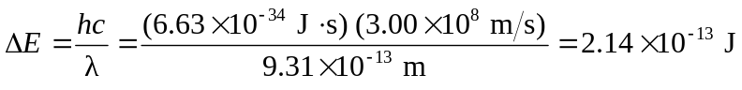
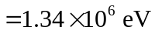
So the number of electrons that can be excited to the conduction band is 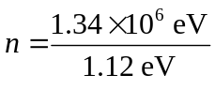
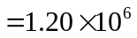 electrons.

